Predicting stock price closes with sentiment from tweets using Big Data, Arima and neural network technologies

Erwin Plaza Copajira
CCT College
Dublin, Ireland
20024033@cct.ie

Abstract—.

Keywords—"Convolutional Neural Networks", "Dental X-rays", "Caries Detection", "Supervised Learning", "Computer Vision" ;” hadoop”;” Apache spark”.

Introduction

Theoretical framework

Artificial Intelligence

Artificial intelligence is defined as a set of robust data to reach solutions to problems. Its origin dates back to the 1950s. The differences between artificial intelligence and human intelligence lie in the architecture, as human intelligence is much more complex and human decisions are generally more emotional.
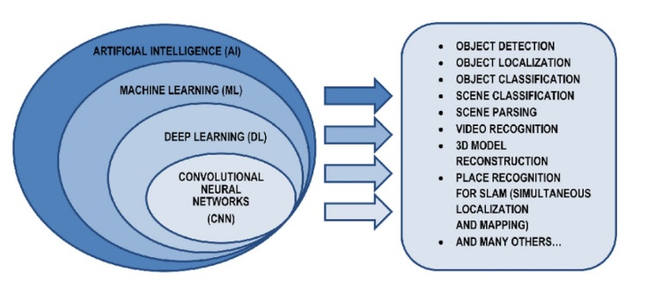
Fig. 1. Artificial intelligence areas.

Machine learning
This is a field of artificial intelligence and consists of machines learning from experience. Within this field there are different techniques that are applied to different areas such as the following
- Supervised learning
- Unsupervised learning
- Semi-supervised learning
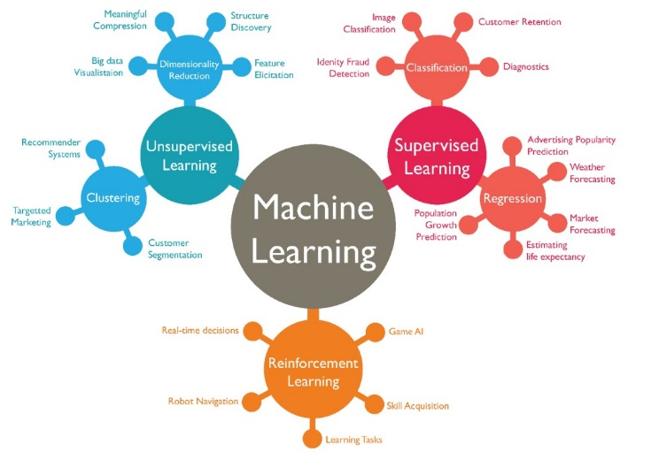
Fig. 2. Types of learning

An example of supervised learning is classification which is a form of pattern recognition to predict a class. Classification is divided into two subtypes Binary and Multiclass. Here is an example of multiclass (Johnson, 2021).

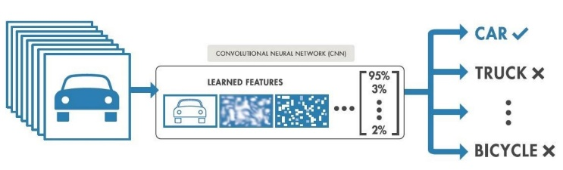
Fig. 3. Multiclass Classification

Deep learning
Deep learning is within machine learning and is based on artificial neural networks or ANNs. Let's dive into what neurons are for now.
Also known as Perceptrons, they are mathematical functions that mimic human neurons.
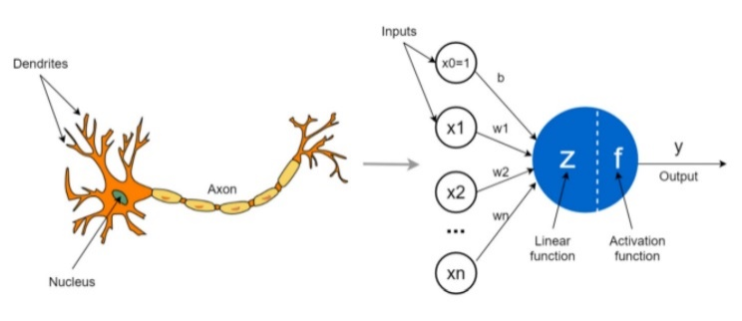
Fig. 4. Artificial neurons

Artificial neurons will have various input signals (such as dendrites), they also have a processing unit in which are the activation and linear functions (such as the nucleus) and an output signal (such as the axon).

Within ANNs there is a special type of neurons which are convolutional neuronal networks (CNNs).

Convolutional neural networks
The main difference between ANNs is that ANNs process each pixel independently, which leads to the loss of textual information along the way. Because of this, ANNs do not distinguish edges, contrasts, geometric figures and other information.

General concepts
In the following, we will explain some cross-cutting concepts for this kind of technology.

- Training, validation and test set: The training set is data to create and improve the model. The validation set is used to optimise the hyperparameters and to detect overfitting. And finally the test set is used to evaluate the model.

- Bias and variance: Within classifiers different types of error are known. The irreducible type which means that they cannot be evaluated and the reducible type which can be improved, both bias and variance belong to this type.

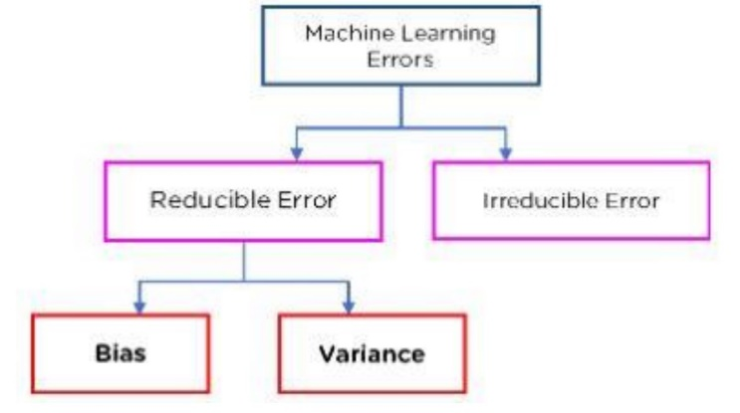
Fig. 6. Error Types

These two types of errors are inversely proportional. Bias in simple terms is the error that exists between the predicted values and the actual values. If this value is very high, it is considered that there is underfitting and that the model is overlooking specific characteristics. Variance measures the variability of the predictions made.

- Hyperparameters: These are the parameters that are set in the creation of a model. Hyperparameters are divided into 2 classes:

Hyperparameters for optimisation, we can name the following Learning rate(adjusts the weights of the network to reduce the error), Bach size(Defines how many data will pass through the model at a time) and number of epochs is called the number of times the data passes through the model.

Hyperparameters for specific models, comprising a specific construction. Such as number of layers and number of hidden units.

- Hyperparameter optimisation: is the search for values to improve the model output. The most important are Random search and Grid search.

- Data balancing techniques: There is a very common problem when training models, and that is that we encounter an imbalance of the groups of the classes to which an image belongs and for these two solutions have been created:

Oversampling and undersampling, the former consists of multiplying the class for which there is less data to balance the training. Undersampling means reducing the number of data to have a better balance.

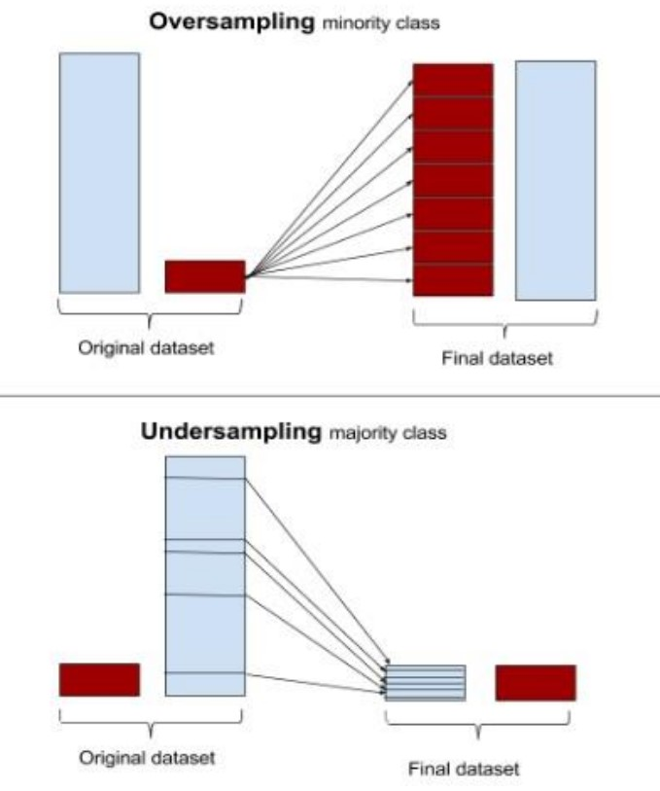
Fig. 7. Oversampling and undersampling

Hadoop
It is an open-source software platform used to store and process large amounts of data.
To implement this platform, you must create a cluster where we find master nodes and slave nodes, the first has 2 components, namenode which is the one that manages where each part of the data is stored and the Resoucemanager that manages the resources of the cluster. Whenever the Namenode stores the data, it copies it into 3 different parts on the slave node side you have the Datanode which is where the data is stored and the Nodemanager.
To process the Hadoop data, use the MapReduce which is to first divide the tasks into blocks to process them and the second step is to join the processed results.

Hadoop is made up of a set of parts that combine to analyze stored data. It consists of four models:
Hadoop Common: these are the basic functionalities that serve most use cases
Hadoop Distributed File System (HDFS): stores data in an easy-to-access format
Hadoop MapReduce: processes data by mapping a large set and then filtering it to obtain certain results
Hadoop YARN: manages resources and programs



Apache Spark
It is a technology 100 times faster than hadoop and the difference lies in the fact that it uses the RAM memory of the computers to process the information, as well as being more flexible at the time of implementation as you can configure it with different programming languages such as java, phyton, among others.

On the other hand, the Apache Spark architecture provides various forms of deployment. Below, we share the options in which you can carry out the deployment:

Local: that is, it could be implemented from the desktop.
Standalone Data Manager: in Spanish, independent data loggers. It is a data system integrated in memory without the use of a local.
Hadoop YARN (Yet Another Resource Negotiator): that is, a deployment in one of the control layers that is established on the applications or commands that run on Hadoop.
Apache Mesos: this allows information to be extracted from local systems and developed in distributed systems.
Kubernetes: you can also deploy it in this open source container application system.



L. Medical Applications
The emergence of machine learning and deep learning marked a turning point in medical applications.
Deep Learning now has so many points of research that it is impossible to have a single area of interest.

Within this breakthrough we find that we can read medical studies faster than an experienced professional.

This project does not seek to replace the expert in the area in question but rather to provide a tool where better patient care can be achieved.

METHOD

For this project we will use the data science methodology that works in an effective, efficient and organised way.
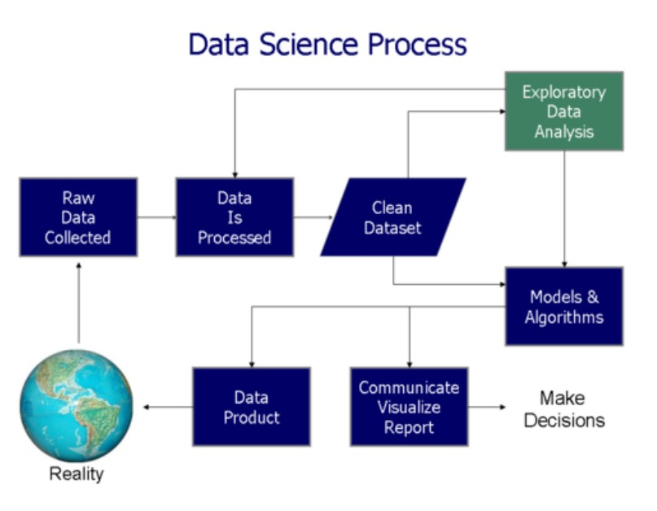
Fig. 9. Data Science Process Phases

The phases of this methodology are:

- Phase 1: Project definition: We must define what we want to achieve and make a plan with the necessary resources.
- Phase 2: Data collection and preparation: Data will be collected from different sources, such as apis ves, csv databases, etc.
- Phase 3: Data exploration and analysis: Analyse the data, what characteristics should be taken into account.
- Phase 4: Model development: Consists in applying the corresponding algorithms iteratively to improve the model.
- Phase 5: Communication of the results: A consensus must be reached with the relevant parties in order to improve the models.
- Phase 6: Decision-making: Here there are two options: to terminate the project or to consult for a new iteration.

Technologies used
This section will provide information about the technologies used, as well as the programming language, some of the main machine leaning libraries and the development environment.

Programming Languages
Python is a high-level programming language, interpreted and focused on readability. That is why it has been chosen for the development of this project. It is also very popular in data mining and machine learning, some of its features are the following: It is an open source language, it includes object-oriented, imperative and functional programming, it is multi-paradigm and has the possibility to write its modules in other languages (C, C++...).

Hadoop
Apache Hadoop was the original open source framework for distributed processing and analysis of big data on clusters. The Hadoop ecosystem includes related utilities and software such as Apache Hive, Apache HBase, Spark, Kafka, among many others (Hadoop, 2024).

Apache Spark
Apache Spark is an open-source distributed processing framework for Big Data. Its main feature is its use of in-memory data structures called RDD, which considerably increases performance compared to tools such as Hadoop(Spark, 2024).

Tensorflow
Well known in the area of artificial intelligence and phyton. The choice over PyTorch was mainly due to the ease of deployment, especially in the deployment of neural networks.
Within Tensorflow there is the Keras API which is based on Deep Learning and written in phyton.

Scikit-learn
It is an open-source module that provides tools in the field of Machine Learning and was built using the NumPy, SciPy and MatPlotlib modules among others.
It also handles some well-known metrics such as the ROC curve and the AUC score, the classification report and the confusion matrix. We will explain these metrics later.

Matplotlib
It is the free software created to visualise data and graphs and provides an alternative to MATLAB.

Development environment
For the development environment we have chosen to work on an Ubuntu(Linux) virtual machine in Virtualbox to be able to work with the distributed systems technologies Hadoop and Apache Spark. In this Ubuntu operating system we have installed and configured all the necessary libraries such as Tensorflow among others.

Jupyter is a web IDE that allows you to run Python code.
Virtual Machine is a system that simulates the software of an operating system.

Data
In the data collection, the data has been extracted from the Kaggle website.
The data used are freely available under a Creative Commons Attribution-Non Commercial 4.0 International License (CC-BYNC).

Dataset
The dataset was created in August 2023,

Technical limitations
In the course of the project, several problems were encountered, for example: the installation of libraries that required more optimal hardware capabilities and that were not found in a virtual machine. Also, these virtual machines do not have the CUDA libraries that considerably accelerate data processing.

V. IMPLEMENTATION AND DEVELOPMENT

The ANN network consists of two dense layers and the Convolutional network consists of 3 convolutional layers so that from the first one the filters are duplicated. It is also specified that the kernel size in the convolutional network will be 3x3. Each of the convolutional layers consists of an associated maxpooling layer. After these layers is the flatten layer followed by the first fully connected layer with 128 neurons and the last one with 4 neurons associated to each class.

Results

Conclussions

REFERENCES

Brown Alvarez, J. & Vargas Zelaida, M. (2016). Methods for Caries Detection. Journal of Dental Research, 34(2), pp. 123-136.

Brown, J. (2020). Understanding Convolutional Neural Networks. Journal of Machine Learning Research, 45(3), pp. 233-245.

Johnson, P. (2021). Supervised Learning Techniques. Journal of Artificial Intelligence, 55(3), pp. 67-78.

Jones, R., Adams, S. and Clark, T. (2019). 'Neural Networks and AI', International Journal of Computer Science, 20(5), pp. 334-347.

Hadoop. (2024). Apache Hadoop. https://hadoop.apache.org/

Taylor, M. and Patel, R. (2016). 'Standardising Caries Detection', Journal of Dental Education, 50(4), pp. 207-215.

Spark. (2024). Apache Spark. https://spark.apache.org/

Zhu, J., Chen, Z., Zhao, J., Yu, Y., Li, X., Shi, K., Zhang, F., Yu, F., Shi, K., Sun, Z., & Zheng, Y. (2023). Artificial intelligence in the diagnosis of dental diseases on panoramic radiographs: a preliminary study. BMC Oral Health, 23(3), 358. https://doi.org/10.1186/s12903-023-03027-6

